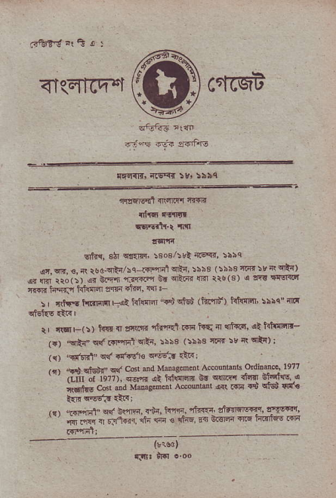
ffi
<I(EICF"I crftqt
sfuf{5?r:fr
^{fjnf} _{ldn} :r6iFrs
. _{{t'arIGIr:t(s<{} :vr Ssbq
,ffacEd {$n fi tffs
dfi c'!{!t
t$l6tt-t {tt
!'qffl
^{qt{{,} _{3h} ^{qttrlt} :€o3/5R rr€q{, !5hq
_{€r,qn.3.4 rsd.tn} sa .6tfi'4ta !!bs _{>rr3t{r!t}} 'l-{) !r {Ff _{tto(i) { d.r-} ^{.ffi} }! ^{qt} _{& m} 5rs/31 r !'!{'srdiq ff{R _{hqlt.r hnnEn} lnr _{ti6} ^{'Rr} .
_{!r} ^{ltttrE} _{trln{tt !+t hillEr "d} ql6i (liPd') r'tuinql':5rc"r'd ci,€t{s €F '
rr r(sr-(i) t{{r { $ruir rhrrel r+1r t{q ir {t*q, a htnnn- ^{.qR{" q(} _{r{lqi't} ^{qti,} _{:5ss} (!i\s 'ri_ir su _{r(} qt{);
^{.ntRl"} clr _{sr.dtu} ^{q.tE:r} {tr
'fi qjsnr- ad cd Nd Mmgdor Aeourmc odiNer latT (LuI or _{197?).} q..* rl i411rm _{9t} q{Et .nn srq{s { _{iartm} c-' -a v.'"gd-t e*odut @ rc{ _{.!i} qlsd q{.
^{.eFtrit} oq _{sffi +!si. i.sn.} ^{-'.@} !'dnF.!q, !'vgqr. _{s a*!r} ^{q} _{r..'@.} ^{qi;} @ o 1i{q, 14 6r@ @ rFrq- @
{tled,
t_l|Jt ar{I o oo
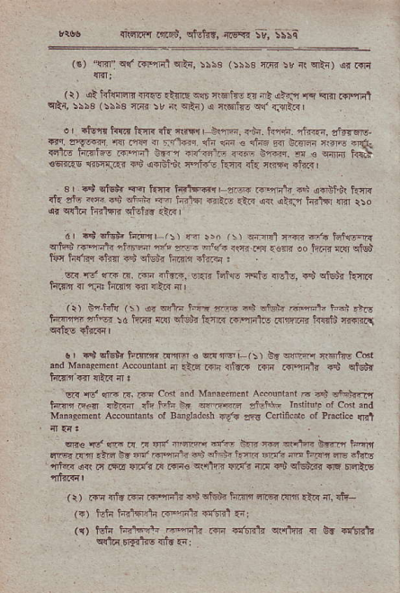
?i6fl.q{ _{r't.5t} ^{qtstir,} ir€"ri St S\'ia
^{(s)} _{"!T{l"} ^{q(} _{mqn]} ^{qRr,} !\sa (:b53 ffi :! _{rl} ^{qE{) q.} t{i (r) (t td€al: _{nriq:inrE} ^{qq6} ildtu6 {ir dE _{{l_fi} ^{'l{ q?r .{Fril} d'ti, rsbs ':\i3 @ :& 7 ^{qir' , +6fe€ r} {4.1F'
o I rtorr hvr ftrR it{ drq! | slffi, n"sn. ffi rtr€n. at3TEre ^{F.} _{?.l@ 6('Ef} ^{rr.rEq {J-{r'€dan€..maftffi} _{drr '} ^{.-'-re} F-in f,c ^{ricF.r+.c*q -} € ^{lrm} h{\ _{!qr..s} ^{r6,Fw$} _{rd} ^{qqili rria's} kcn {ft rqrr +trr I
_{s} ' _{..i Elrrqr.} ^{q} tft _{t"rfffi} ⁻ !J-E 6'in\ '+ ^{.d'rn} f.4{ .'i{ _{sto} &n 3d EH{ @ iRl+r @tz! _{rt{r} ^{qa qndj iRrsl ffi rlo qr qdR} _{tRtsr{} ^{qt6hd} anR I
dr +q! €G' h@r t:) Fr>o _{r:r} ^{qrzd} N,@ rrr tutuoqn 6rH _{eirilr riiffi} ^{,F} F. FflA <qar Fr{ a€lrd _{oo Etn'. lRt} qt6ua f;rt _{I nsr} ^{d?q a!u'} ffr ii.i. dr.di:
_{$i!} ^{td} @ R. @ df6. d*_. _{H-F} ^{'6tu} _{s!tE, rS} ^{qfu.s{} fTrrR tsritn rl,rm h.in.r] {ki irl
^{(r)} bqhf{ ^{(r)} !r ^{€dF i.*} _{cft} ^{*4} lMr l#|i ^{rr'f} lttg l.dn4 ^{'rrq} _{:d hrrT ftr} ^{qS{} i{ar< Fmilr ^{dhlri{{ ffit T{fGr\} qdw.lirql
!r $4qb{titlm!!l@s@Fi ^{(:)} 6E ^{liJl!fr} _{r.-6ftG} cod rid ^{Manag.nmr Ac.oiknt} {r rlIq _{mn rltli4 iTrn r{r.nit{ .S} qffir
^{'w qd} lrF a, _{i?q} c6t ard Mamensr Acmihnt E !6 dffior ts@ F€ r,nd dq tsfi 6r _{ffi !M!}i} I'niff. or c6t,id M'Das.n@r AcMrmb ^{oI Balcladasn} _{w9} grs ^{Ceni6ce of PGciic.} {Bl
uR.!j'd@F _{?F-e*'fr} ^{-- q c"'E} _{vltf,} hnrn 6@ F *6 6r 'i 6Frir? dn ^{5tur r.e} di!'? ;m t'.{r _{re} ^{.tos '} rfar aR r{ LTE w{r _{d .+rqs cv}rd $16"r rF r$} ^{qid.ir} @ Fqtls
(i) rTF rrfr .qi .qqFl 4'i cfun. hFn ner .m *r! 11 !fr r?) Hr iiia {a @';ti -:rtf F,
({) l!$ _{iE} ^{-fA r"-n'!} _{.fi} drffi. n.lrr . b. .rt-'lr ^{qda} rrEitrc nfr {i:
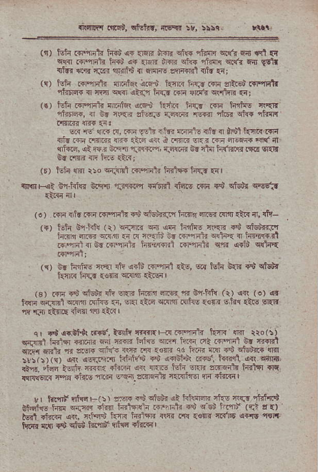
_{rir{,F r rqisb,} ^{qtqkr,} ft€Yrl
(t) isln r+lffii trri,!F {q? ir{r _{en$ ftw} ^{q.!rr qn} !,!l € c!-{r llF,qlrft inid !F {rnn drqir en€ 1l?{r e.(i ^{Edr} ldn ^{q'B} lTr _{t:rn} ^{'ctrt} { ^{rrl+} aF-dd ^{{ft} ti: (c) toii .{.qrch itnf&r i!F.i klr6 h{r iar{ sdrEi i{rqEtr _{r1i!ra{ { cra} ^{qe.cr} a*n hrn .{r flna crrlflr {r;
(€) _{iilF t{rqr4t nEatsr} ^{q.qd} HR _{h{J .rrn ffi} q\EE niim", fl b. ii{r _{zrl!;,r} ^{q..l{,.lr} {Er'{ nhrr _{Ei1}} 'tufr F1{rtri c1{{ {i.
_{lir !i} ^{q:r} .{, ^{Fr} _{!.t} ii5" wdq rn6 { Nl kit < r{'r $ta F{ mim {ir _{alia} ^{qrt} a _{irm Er.r .fd aFfia} '4rf ^{qtuq,} <i r.{ nr.t'r,i-F..q, {:".ffi Vd cl-{ h(lirir .16 6RI{ tr m. <lI ftri {i?;
(E) t ir ffi iio c;!-q'rl r{'F iii" t{rlf{ ftr.' rn I
{rn, _{o:} ^{glit'E} _{!.m} ^{.l3r.!q} flffi rlRo nF {."'lr,jr 9@?
(o) Isla $tu iql{ i4lF{lrlr +d ctou!ff.ri hiT'r ^{qr.€r} nrf .ii{ ₄ {ft- ^{({)} ffi E,rfd{ _{ir)} ^{qi.rrR qrJ qin} hf{F m'{q d $6n{d.Pr t'r{rr _{ffi w6.n} ^{q} ci-fn t..fr{ntr s{h{ {r ft{'i.|Til r?ffi1{6r.mFt{ _{li{rr.F.{'t r{lqn}i s"m} qd,'cqir{ r{r{il l
({) Or hli€ {{{r fi aiti .r'nil _{.i-,} ^{qs} _{toji b'tR T",'} qffi{ knr.s h{e {€rr* ciqfi tiilq I
^{(s)} rn ₊₆ ^{qMr} _{sii} ^{q{r} trirE _{aiq s} ^{g{hf{} (t) a<r (o) ar _{t€i} qdFnl va{{ rfi! .a, sr{l _{*rr} gRM ^{(nN} <€{B sh:r .lio srali _{fi'r^rl} q:r(E {qir n {a.r r
^{qj} +i {dBtt( rrrd,leiir rtrfirFr:,l ta'{{lil _{t{4{} ^{qr{} rro(li ffit iftl6l _{iffi} qir :jm _{H{s} ^{qr.q"r} hrn .rt .{,-rd B. T{{ltl ra. rrtj'jr :tF ii.,E-.'tr r _{t<irF} q4.?4. 'iq^ {i titn"r4 @ r,'iF n k.Fa oi 6'ifr' .{+e i@f i. 9q
_{+{.} ^{,6E} 3:- ffi. { _{"F. .- qTj} ^{cq!-"} 'f 3T@tE ftr.lsr {IE _{RFRFa.} ^{'b'E .nt} "rir4
Br i{rqd nlmF(r) zF _{i.i} ^{ql6!} a\ hlffi ci.s ir{F diffi _{tffi.E tsl!} ^{q{riq} <in t{{16idn.+.6h _{ei} ^{q_su'ffi} _{{r.l} t{) _{H} 6iRq i+, ':@ 'in'nria aft rr.on ft.'6 _{o..E} llrn fqrs {BJ d s!5, kmu>'rfrra .J{rd I
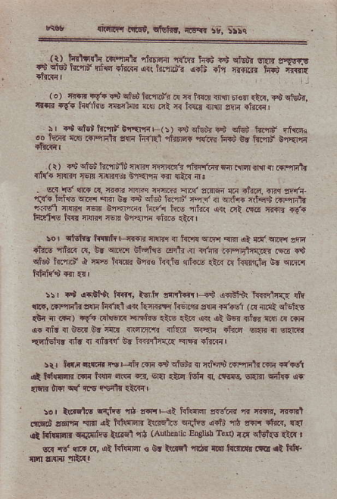
lrlinrr fid, rfthr, irlin it, Sirq
(!) lf,v{"r r+r'xtr! _{rfrEirir} ^{'{.F} iqus .t cur ^{llnr !4vr!} +d cis i4nd ntvl {t{Fi {{r frl1rdr !.in r1'l r{.nr{ _{i d} ,ir$ir (.) ir{tr lv? d ctd h!'inia .{ {r h{n {ryr 6rsri.}.{. ^{{t cnsAr.} t nr {f. _{htrire} ^{qr!{hE} ri$ oR T{ hlli rn$ llrn dnm l
r' +lctutflrdErflf'F(!) 6d oG! da .G innd CGx o. lftR &a FE3t r{r I{.f t{Err+ ar6i iqB 6r ift"rn C-{Im
(r) _{!S} ^{qiei} tur'nifi n!]r,r i''n nt rti{64 6dr m.rtr]{r rT.nq+r {ff. aMm rEn {{lrr,r: B.1anni sr {&& ar!
. sr{ !d cr{ r{, F{rtr {nlrq rmirn <lr{ !rcr6{ r.i rtu6. dr.r ^{l1fi- 'rtrF} _{lEt1o} ^{q].r'r} _{Rr} ^{q.} 4$ cf6u tn,|llr r-rf _{n} qth{ ^{'RH RHdt} ,lrrsl :i-@ :B 6qn.& iiiar hG rtor d( .,i .ro I1r, rf. ffir6 tfl! amrc {qr ir'.m +1@ zn" I
_{:o,} ^{qtulr.} f.rifr ! ^{jr{ri} nm{.r { _{tonr} ^{q.qq qrfl} ot _{{di} ^{qr.q{} sflr _{lt!?s} ^{'nh.c} _{c, 6r} ^{ql.r6} Bffirq crft{,{ r'ftR.sm,rtTJf{ r$6 Ti # ffi,n ciE lflrlT B"n€ FEJU ^{!ntr6} _{<tn} ^{q} fts.{,rh _{E} qlnn
_{!: | .l} ^{qrdln} ii"rr, ts,fr _{lct+a Fd} ^{qrrd"ir} lffiry,{ rlr rt!, .frlEtr !!rn tfit i {r. t{rFiFr f{6on slE r(ad (F _{{.!t} qlEl1E {t{ il .€) rC{ r{h6rr{ rr"hE _{€.8 {tf{} ^{qR qn} B6i ntn{ ns d .rF oTrfu{0e.rorc{rd {rr6re.Tr {ri{rr crri ddm Elr:l { Gr'Irfir {drfulllf dr 1T {td{'f b. h{?l}:r.q _{FrE} qto{r'
rrr t {,i ||nd. flr-{fr.{lq rt cisi{ { 'r,F+d .{r.iiq}i.!li d€1 d Fi{|rqF rrl1 t{{n !8ri ^{?4 ecrl} .t@I l6i{ {, Ltrs, 6r.ln {rf€ 4r int{ dIEr sllf ct{ i{alr {i.ltrr I
_{lar tl|rrF} ^{q'tft6} _{Tr| !'{'!!+t kftl"lT srt'ar} ^{'s} _{rrrr',} :|r!]rt !|Fd ,€rd _{errr} ,rt htIrcII _{\nqts} ^{qdis q+l"i} 1l} r{]t *r.{, !'{ {t _{khrE} ^{q@rfis} _{t{€1} qB (Au!b ric Eqlist Tort) _{ii} ^{q19t{s} a:.I r s{ d rlir .r, 4t ftftrw s tu tmrt idr rE! ftnrd{ ^{!fi rt trlr} rlII !r{E ]aRl
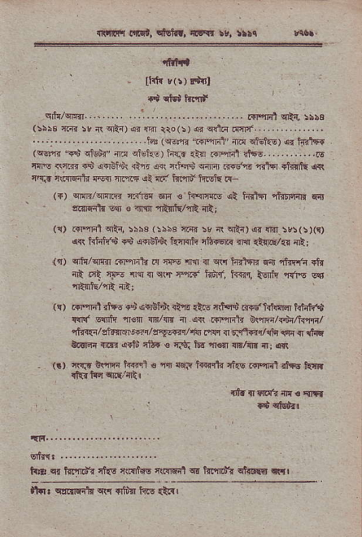
{rtl!r{ _{Fnd.} ^{qfuf.r,} xfir rr, ||!i
nhnil
_{ttrtr} v(r) d{l
.$aMt.-n|.
qdr/wx{.. -...... .......................... _{Rrryit} ^{qE{,} :rbs r:5rb @:r 4 ^{edir rr F} tro.sJ!r@ldd#
'. .j-. . .... . . -.. la: (rsfi t Fxl'{ri ^{cteilE) ar} hd,r{ _{(qq"fr} ^{'5$} _{ctgii" {tr} ^{qisiEG)} h{.r .tll .l'rqrl rta6............N rnic ^{(i..{} sd .e{lBlit _{a"lr} ^{q{t} l\k crrdr F+s'a. r.l'fi _{finto} qR ^{qq_a} mfff,dn rvr _{cn,l|4} ^{qi} lit' t{t?ld'ffi rr-
($) srw/dn'mi? rF16q 611 € _{h,cinrE {t hitri} ^{qlilrfl)r} Fr lr'rf{lr Ecr € irHn TRffq/flt rt;
(r) _{.{lr'nnl} ^{qti,} i\b3 ^{(:i5€} _{riT{ >r i\} ^{q'?a) q.} {lil :r:(:xr) _{a{r t{hffd +d} ^{q"rinu\} kfifr nfrrq.{ flll {imE/q nt;
(q) cric/qrffl .Tr%dr.{ iF {1r { ^{q{} hrt$r fdt nfuEl{-n {h {R.rl cF {r{r{'qs{q.c t{h(, i{{rq,5 k r{re Gcr . T*/Tt rii;
(!) r{'qlit rnft fi o{BJd {tf4 *!E {ffi F{dht$Idr khft€ _{{cI{} q6'i{ ^{,fl€{I} srr/{r ir dl\ r+rqFl? nvnri/r.dn/tr"nr/ ^{'rtf{{i/slF} Frsr/c"F@n/nr _{ns,r 4r r..RFrr/dq} ^{,!qr} { rh tulqr _{nFr} ^{(rto'} ri'{ € r$; br @'r {n/ir! d j {d
- (!) ^{'r{'.f} ktrl tqFn € at ff.q t{{..llr rt{E FF{d rl'E n{r{ li{<Fi" crLV tl
_{{Fr.-......,.} ... ...... .,.
_{stn'.} ... .......
t _{E} ^{q!} ffi'a nf{s fiEiEc _{i".i!rf,$} ^{qd} _{ffi{} qtrDEir qq' _{ahr} ^{qErrlnlr qr.{} {t!Y kis atrr
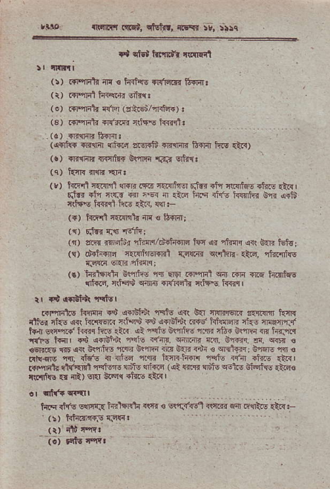
,rto T(tqrFt _{ordl,} ^{qtEf.r,} rrEY{ :r, ;:!q
. Tl cffi ffir rw.4,t
!r t||Ftl
^{(:)} .{l'rrlln fl € krfav TFtddi frm!
^{(r)} .+Pil4l t{<inir v:rtn3
^{(.)} r.r"nat i{'{ (rldhd4r):
(s) .dqit {R'".cr {rJ4.€ FTrfi.
^{(a)} ..B{qR lt{rrl!
(,c{ft{ {t"r4r c]i-.{ sruFli {rflrcri trqq ir1o {t")
(!) +RniF n{nrlr{ _{Um4} 'rdi{ qha:
^{(q)} _{krr{} ^{?I1E} {iqt
(r) _{h.rd r.i!r^rl} ^{qrqlr} iE.' {{r,rfrr-r rlrrr itu nlr1]t6E rftrE .t{ I Etu" 4lr n$i6 {rr .tur ir .i{ tiiq dr's ffin R,f{ o+ia cll{E k€r1 |ft. rlR, sll:-
(r) ftffll14iEFh@ € fr-{I{IJ
{<) silcr q{ 'l!lh;
(r) a&{ r{],iiu>r rh,qr/iili{{tra F|a ^{qtr ,tun} ,sr( Bm tri<; (s) dd{dr4 _{iri{fir-RBl TEr{r} ^{qr{hlr} {i6, da.|l]lc T.C{in sr{ir.rJrm!;
(.) inl4'dr Be'fiE 6 El$r _{RFml} ^{q{r} r{r4 rrc h.Ttqs {i$id, _{r.iq$} ^{q{Ial} +rffir aiie$ hlrll
.qqFlis hrFlr r$ _{a+ritdurafs} ^{q.(} b{ cRr+M.{ sot{4 hn{ r1tur _{-t E} ^{q<r} t{'lr€r.! _{ntH rS} ^{qooi'u'r} F{s' idwrF rks ar@rF.r' _{t{il} ^{qpl{'t{tr} ftir {i|{ ai _{nqtu} ^{g(Tdt-} _{lm} ^{qt}.r} ss"rB ni h.Jnq {{'E tflr _{{s} ..il.i. ^{q\} rft _{5i''m} ^{q{.} ift. d, E@ g €Er<.e crD _{r{'} a!'r'i4 ^{-Ie} }m @ b{ti r4i 3 rNt@, c€r r s € rd!€rE nr. rt6's { {d@ rB t{4nhfl{ iqtu rr'{ riaiE {inl _{r6nflti} 6trEi1fllei i _{ri,} ^{qtd.?} _{it tilq} ^{qt} , 5 1Lr .rldi{, rLd< _{rsrtf' €! fi)} 6Er S.q{ +t€r .2!{ |
_{.r} qff. q.'{It
hrq rf.f$ s!]I{.{ hrltidn .(a{ € E\'13.{.l ^{rrli.r f"rl &{fuE} _{{aq} ts
(t) :i16 t'fit
^{_ j;)} F{tu +'iil
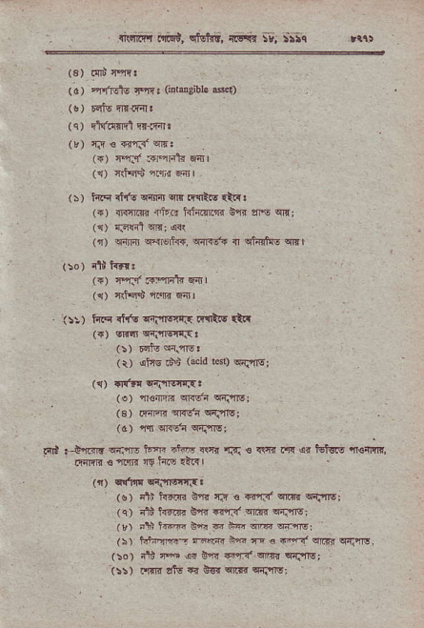
. .Rnrr.r _{ffi,} ^{qtdiit,} aiii$ ;t; !.:a i$
^{' (3)} !!t Prt
_{(o)} ^{qf.d|r} _{++ r} cnti4ibl. d.u
(qJ Frrll:'EEl qr{e,rr
^{(k)} _{fi! € .{'r5} qr.
^{({)} m.1. _{;+flFtR} q.{l
^{(!)} _{ilioiu>} ^{'iri{} f;drl
^{(s)} hF _{rt{q} ^{q_{t'ar} sn R!ftq rLrt
^{({)} e:rmi n4'6 hlliw.lq b,ri _{ar€} qrx;
('r) {Ff4t w: a.l
^{(')} sijnr c'-{lErhr, wl{sr' _{n} qtfltu6 q
(to) dli t.d.
(+r _{cYJ' FqFL} rd!l
^{({)} cltqi> rFn 6 |
' {::) i{q r'irt {td!ar{ !mR.q {tr
_{({)} qfir qflqif.{3
^{' (:)} _{tqio} qi."ns:
^{(r)} _{afrs.B\t} ^{(tcid} eq qrflsl
^{(tr)} _{rt6E} qtflEfi{!
. (o) _{{€nK} qrcda q{'frs;
13)riryFidnJs:
(a) _{n} qR!tr qrlns;
at .j'.rv ^{wrro w.} _{"t'- r\fd} ^{'rfi} e rtnr iw ,ar _{t3t!6i} qrsnqR, _{.rrFr !} ^{'rq} ₁₉ lts tta! |
(n) cE1'E cirig rs!
' ($) _{itt tFFt tTt:fi € 4",f3'qrR} q{'il€;
(q) -1i k?rF _{6a nrl} ^{qr{.} w{rls;
(u) 1l!,' fn@ 6r d na rim w-@i
(i) h+qE- san3. i* _{n € r{'r"'} q!r'. q{'1rs,
(ro) _{ati ift or 66.q{} qi*{ qiiirs
t:!) r't]. ttu € 0s. @'ta 6-.'nv:
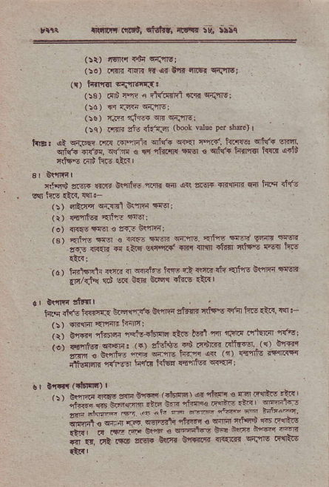
rrit _{r'{,wt a!ra!t,} ^{qtfir,} n6" !e" ili!
{!i) tsT{ _{{6{} q{irvl
(!.) i{rlr {r4n tl ,er !'rd tnIsr qfJlrqr
(r) _{tsfir...t} qnr6iq.{!
(i3) .ni {Fn 6 fl{d{it {q cflrs;
^{(:6)} n _{d.Eti} q{l|rs;
, 5s _{i} i.@ _{'1F} ^{q s-rre} :
(:cr _{.s J : dlt'r} ^{'book t'lu'} _{Pd} !bd'r I
L!8. _{at} ^{qfi@} i|.s _{.qqit.} q,i(+ ^{qi'{r} _{nan'. hnr!:} ^{qrtuA} !M. ^{qiri} _{{r€r.} ^{qlr:{} € q ^{'iii.'fl{} _{{Tqr €} ^{qlqft} _{h{l'r{r her} q+tuj 4(trE .rri htE Qdl
{ilqi dcF {trt B\rrtrF _{tsr w} ^{qn} a!6r{ .E.m {dr hF 4tro
_{(:) 'fl:tf{ q{.od} ^{qrnr} Flrl
^{(r)} _{{t{tq'Tiit} 'r46li
^{(o)} {rf,6!e€?F.ns!f'Fi:
_{fu} ^{o"ot} _{"r} .".- ."*,r {Eq dr .tdr-i6a .6 !-nr _{rd) tFld{h ffi a} ^{-f{"! in} _{".!'? r'r} ^{q+} ' :!€ .rIF _{?1'l/Tl{} Ed w }fr erh{ d?rc .n{l
c I Gr'lri dFnr
_{lnsriftft{.nE} ftqrrrlia o!'ifl,l5inn rrts$ {1'{ irE {t''. 4n '- a:) {.{l1 {1'1qB lrntr
(r) Br+tq _{nJrsn} ^{'I{tu<jb{6} {tv l6d _{r"n} 'r.ftt {r'lftiFr{r.l ,6r _{ffi} ^{..i} tr+cG fd6 ^{{ c-< -} zqn o _{€r-J.} -q _{Fft} ^{r-n.} . ., 4u{i! r--R*r _{ittotrn} ^{'r{1'5} hit! lrisF _{{€nrfe{} qfcr{;
_{, ! r 0r1tr} ^{.{.EE} sH _{b'la .16-:?1 !'} ^{qtal} 3 .- _{7"-i} ^{:r? '' ;,r.i.i} _{i*-'-.-. *.. e'-} 'ldqc ^{*-} _{"n} dr6ta
;,.;;*
^{i;-"r} _{" F.ft ft} ^{q.r.{iq} _{a@! a} 6F _{'i€",} ^{'6 *q't} _{t*4, a} -r * _{e* . *--"+-' i.{ +a} ^{-ffi} a a s at tlg *",r. t'Fn _{:'R-i} .r.'B --ft Fa?i:
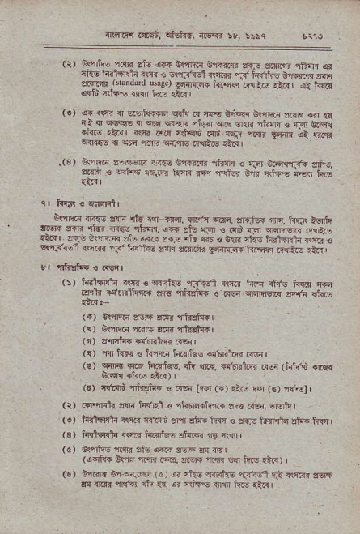
{t4.ri ft64, _{Ij-tq,} ^{;{ffi} 5r, :i.q
r _{[5ho} ^{qm} aro ,a FrDri \@F rrf e{:m iiNr ir f? I ^{Ldq{"r} 4& 5 eqt--] {rG - i,ffi, rc.q e.nr ^{eanr} ₋ ^{r-od,.d 6rd.t} _{Fn@} hr@ .4r. .'.. , ^{ja hllr} oflri 1:I+\ {rfr ]E rti'
(a) ^{q+} _{<fr { dsrhf@} ^{q{i{} F rnE 6Rq GvlrRi ^{asrr .r .{ '',} { 'ria, 4 ^{'uq} ₄₄ ^{qttr r@} _{€E} ^{-r@.} o e ^{F@1} .,4r .t! _{{.ft} 4d ^{'+qc} @t ^{16.r. afi} _{9_r ,5} qm ^{!14{f5} _{{r} ^{.;F} ni 4dnF F{EG .lr? L
_{.(3)} ^{q<rm} ?rw.!lR ii?t b"nr{!i lin.r € r.4 u@m.ft si.5, smr € wird ^{,qi6. htr rsr Fj!.r OT} _{{hr} ^{q-<I} ire
^{qnirq} mriE s{a rt6 r{ +{a, wc,{ ctra, or€Jrr '1rF, h'fi tljrk _{lrr 1r} ^{-"'} _{46r} ^{'Lln. r@} _{:i.} ^{.F} _{. r :r} ^{qffi} F{t.. 4.G _{Fs l.+F.@} rJr ^{.4r<} f. : ri. @ € ^{3r.} _{"n} I ffir a!-r € ^{qrSif} (e . ₃ fiYr's: _{|i} ^{. enmr} _{C:llJ.fu t44} ^{p{"t} 1 _{-n} i !, ^{'|'h!ti*} 3 .Ml
^{(!)} _{ii4"*h} ^{if.} € ^{qilft} _{F-n} ..e hF ^{d.!} k{d a@ F\ rrrh'?a+ _{xqa} ^{rr.E&.} @ ^{FqrR} srtG r.b.,
(rr iF'F a.$ .dr rffi{
^{({)} _{d'j@} ^{'i.;r?} err ntElc{i
^{(.1)} ,frtfi a,t'di1tr' t{€n I
(s) ^{llll} hfl € hn.r h..I|@ $!'n;n({ .reql
,€r ^{s'@} @ innj&e. e! @ €st'r .r.n (ia6 rrcr drcr +i{s {ia) |
. ^{(r) 'Rlqr!'} _{"afRrh{} ^{€ R-n} _{iftr} ^{(r)} _{dr'u wr} ^{(€)} ar?.el I {i) _{rlinlrtr} ^{gm in?t e} _{"didq4iqiir @ ffi,} q6rhl ^{(o)} tritFldn R{a {i1irt sni !ld+ hq € 6d6 tdlr+a et{{ kq I (3) htlFdlr *ryr h.rfr si{,+n ry n1lJll
(dr ^{B'-\} _{"r-} ^{n(,} !< 1R4q{'
{ad1{4 _{€wr} ^{'n} n4 .m, ffi 16 s"n h6i *i)
(o) _{6n.4r on} ^{q.rq{-} ( 6 ) o{ _{cftF} ^{qir<i.-} _{"|J.cl} F* {w"" 16r$ er nr{{ rR'q. rn 4r, ar niEr {n1n ir.! {tc I
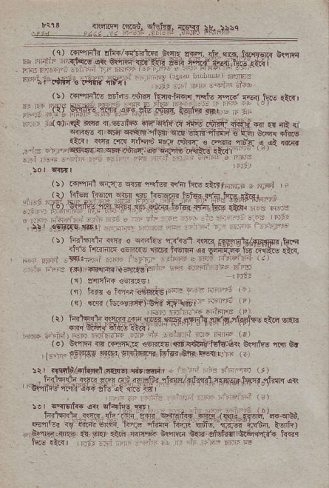
ffi{ifr'}d*
^{ql'l} _{rqtu?} ^{qftr} hrg.:rrhBrF , ,nFt , r Fet$F,FJg',s.$.t"r.sdqr-,; dli
,t{,q
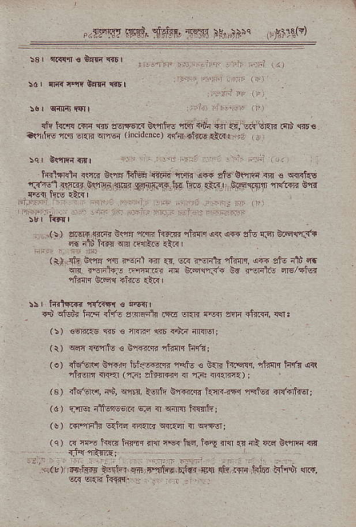
*F's7 rs$, _{s,$'{fi,1w} ^{ruj ::M} L.Ei\(t 16j nirffi &|i {nr
!q| 6rTrr nFl
i{r'l.n{t{ _{{|c.c} ^{griF} _{hteF} rtil.-4i 'aqln qr+ atu'o|,nqr Tr ! c{rt{s -F.e_ *n {i ^{Br4R} -{Etr4 _{Fan?F} l'' h.i arzr | }aqTqn aFftaF ta
(s, ,@ !@ _{0s ar'{flE !'rr} ^{.r dG} _{ri,} F b.@r.'! ^{q6} ilt kd{ an n nl(! €r{,
Itr _{.i!} ^{:.8 qq} 4,,,' ^{d} a. R Fn\ ltr ,6 rtu ilt ft _{6.} ds5i, ^{'!ffi} n 6-ffi _{h tu@1, 6-E} q.- _{"il{lr} oFqa di|- tn<l
rr 1 _{t4rlr?fr} ^{'|qhr!} 3 nir{lr
_{rd cMr hF dft aFrili .!l.d} ^{qrr} rEs ?i!In {td.rn, {qr !
^{/s)} €aFE @ € ryf @ {d? ffi,
(r) ^{q4r} mfd6 e nn4?B rtufiq iiql:
(o) _{rtrsr$ SFn lif..l'im} ^{rFfv} € ^{gtir} _{hz.ds1} ^{'riin{} _{tsr"rr} q{ t'nfr ^{.c-} Lr.a ,i"l@ { -l: ^{.-@} r
(E) _{rnfdlr, iS,} ^{qi6r.} S b'F{rqr _{tn r,r.r} ^{'r'd6{} {'*{i{Eri ^{(a)} r:Ijt! ;rtinre6c:1 6F { ^{qrrm} i{r{fr;
(!) r{r'init GJra _{i4{rr{} ^{qr.r{} { qiftr;
(r) R tr lrs6 fts'.q iM {6{ fEd, k{ fl',( 5 r& ciE E!"lrlq r]|I
^{y} iL, a?e 'd'Fr .i4 x'Fti..F.'rr ^{glt.ii} _{FF} ^{t{j!d} t i"d' aLr. _{@r} ^{qqrl} _{rT{+r.} ⁻ . \:
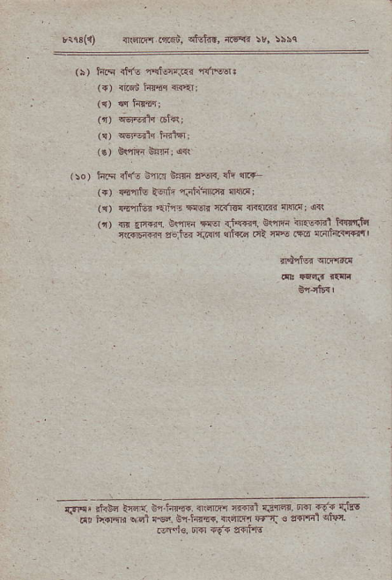
!1$(1 1nsE{-q..!l.{i, clEtrr, rs'{{ t}, lrsq
(:) t4.q {if6 _{iqisrr.!.d} 'r{rsq,
(-) {tf,i hn{q {.=r;
({) +Isrtc {Erq,
_{(s)} ^{qsrBlr} ffi$I;
(!) frr Bdrirqrl
r:o) t{q dr'E i4lr{ tFi4 eR; rh {r-
(r) !.f4tu _{lsrfr} .f.rhhrF{ flnc;
({) @'nfEr _{arl'E} ^{qrq.} ra"]l'|l rl{trn _{{r{n{i} q{
(t, G _{{el} ee-rr '€ _{{i'{F,} q\m .r{v+h' hqFd.n _{ri({l {@ a6jc ftft 6"G Ft c.ft} ⁽¹⁶ 4Ftr4"i4{'
_{&N'} lkin _{t"r,. c" hE{ ffi,rtl} .F.t r.Fra. r ^{iEr} {r! _{i.i h(ffir} ^{qd} !9 _{E} ^{.httr,} n'.q@ {tT . s'!Fr4 4{t .ea']e. Dm {9.a ?'{ri{t

